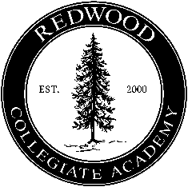 Charter Academy of the Redwoods

Regular Meeting

Fullerton Classroom

(707) 467-0500

June 25, 2024 * 6:15 p.m. Open Session

Welcome! The agenda is provided for this regular meeting of the Board of Directors of *Charter Academy of the Redwoods*, a non-profit public benefit corporation. All business of the Board is limited to these items and is conducted to fulfill the mission of preparing students for a successful future in safe, challenging, well-managed charter schools. If you wish to speak or present written comments, please notify the chairperson. A copy of any items that are identified as “back-up” is available upon request.

1. **Welcome and Opening**
   1. Call to Order/Roll Call
   2. Adoption of Agenda
2. **Regular Meeting—Action Items** 
   1. **Approval of the Prop 28: Arts and Music in Schools Funding Annual Report**—The Directors are requested to approve the Prop 28: Arts an Music in Schools Funding Annual Report for *Sequoia Career Academy* and *Redwood Collegiate Academy* (back-up).

**III. Public Comment for Items Not on the Agenda**—The Board reserves 10 minutes for members of the public to address the Board on items not on the agenda and within its jurisdiction. The Board is prohibited by law from taking action on matters not on the agenda, but may ask questions to clarify the speaker's comment, briefly answer questions, and refer the speaker to follow up with a specific staff member.

**IV. Next Regular Meeting—Tuesday, September 10, 2024 @ 6:00 p.m**.

**V**. **Adjournment**